Create Ubuntu Instance in AWS

Download Java, Maven and GIT into the Ubuntu Machine

JFROG:- It is an artifactory management which store all our binary files which means .class files and it helps to store all our artifacts in version wise. It will also store Docker images.

It is an open source software.

To install, follow the steps below:

First, install wget and other packages if you don’t already have them installed.

sudo apt install wget software-properties-common

Then run the commands below to add the repository key and file to Ubuntu.

wget -qO - https://api.bintray.com/orgs/jfrog/keys/gpg/public.key | apt-key add -

sudo add-apt-repository "deb [arch=amd64] https://jfrog.bintray.com/artifactory-debs $(lsb_release -cs) main"

sudo apt update

sudo apt install jfrog-artifactory-oss

After installing, the commands below can be used to stop, start and enable JFrog’s services.

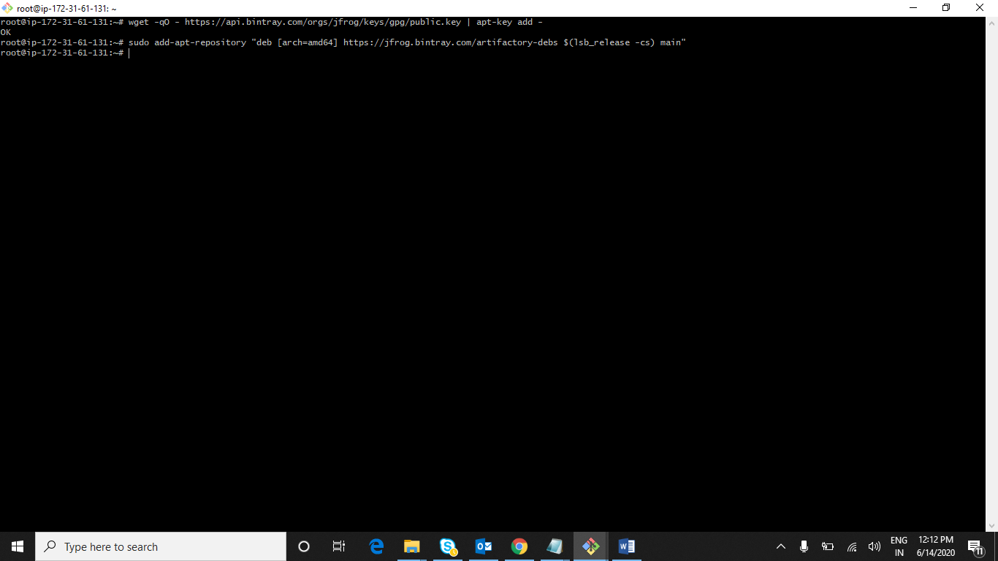

It install Jfrog software to Ubuntu machine

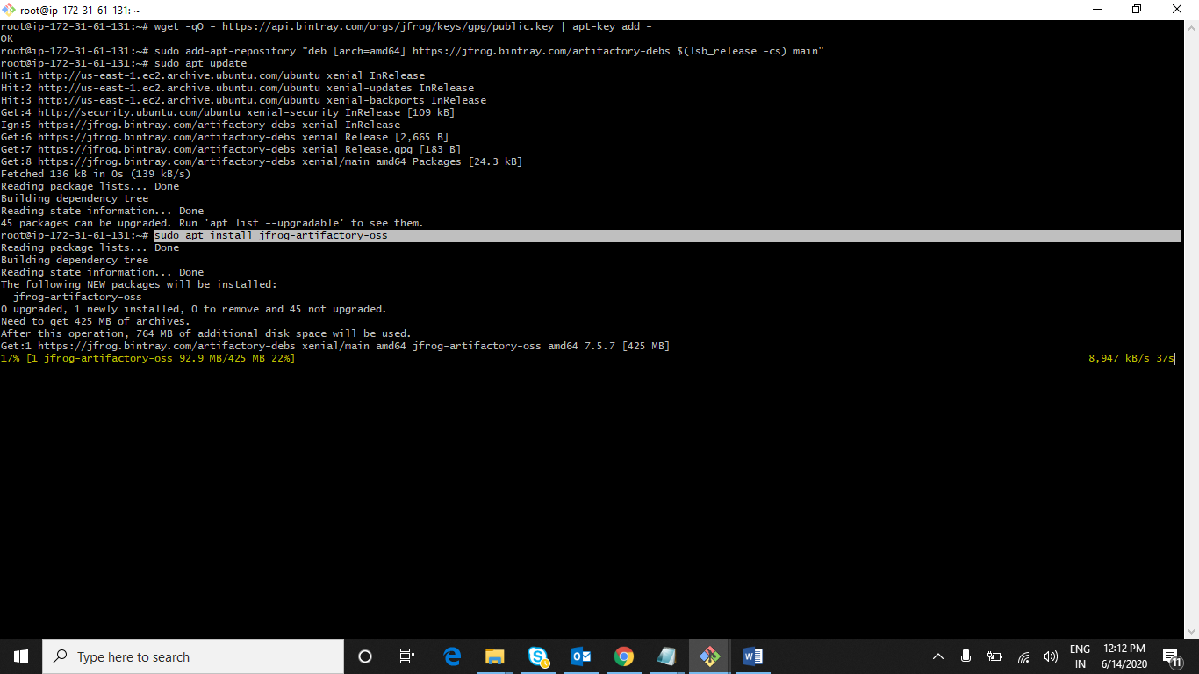

**Start Artifactory Service**

systemctl start artifactory.service

**Below are the commands on artifactory service management**

systemctl stop artifactory.service

systemctl enable artifactory.service

**To check the service status, run the commands below:**

systemctl status artifactory.service

Once Artifactory service is started check IP Address :with port number in any of the browser in your machine it will successfully installed and into Ubuntu machine

For Jfrog default port number is 8081

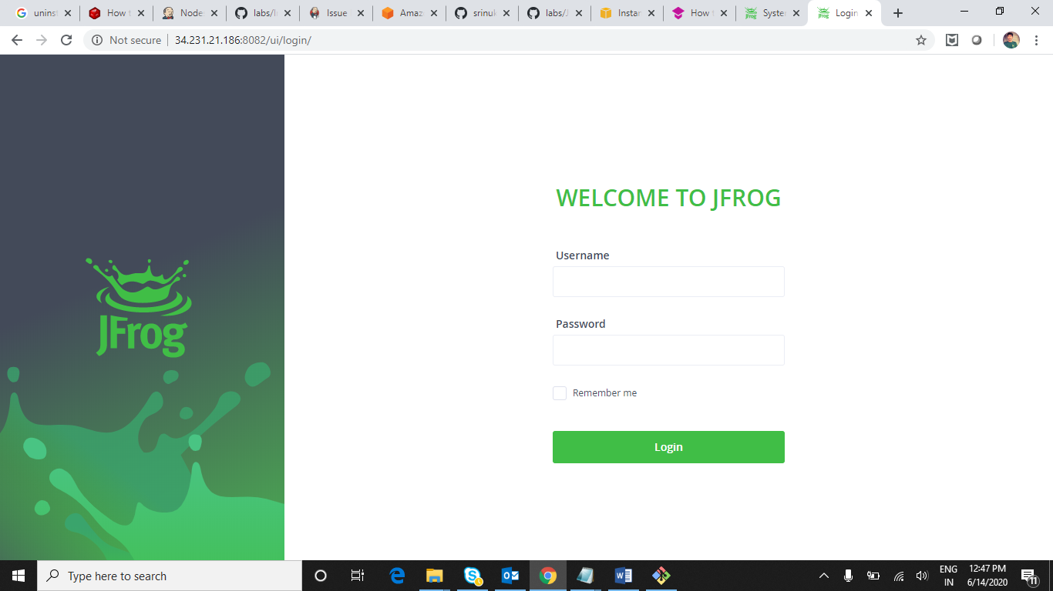

Default username and password is **admin** and **password**

Once after login it will ask to change for password and click on Next

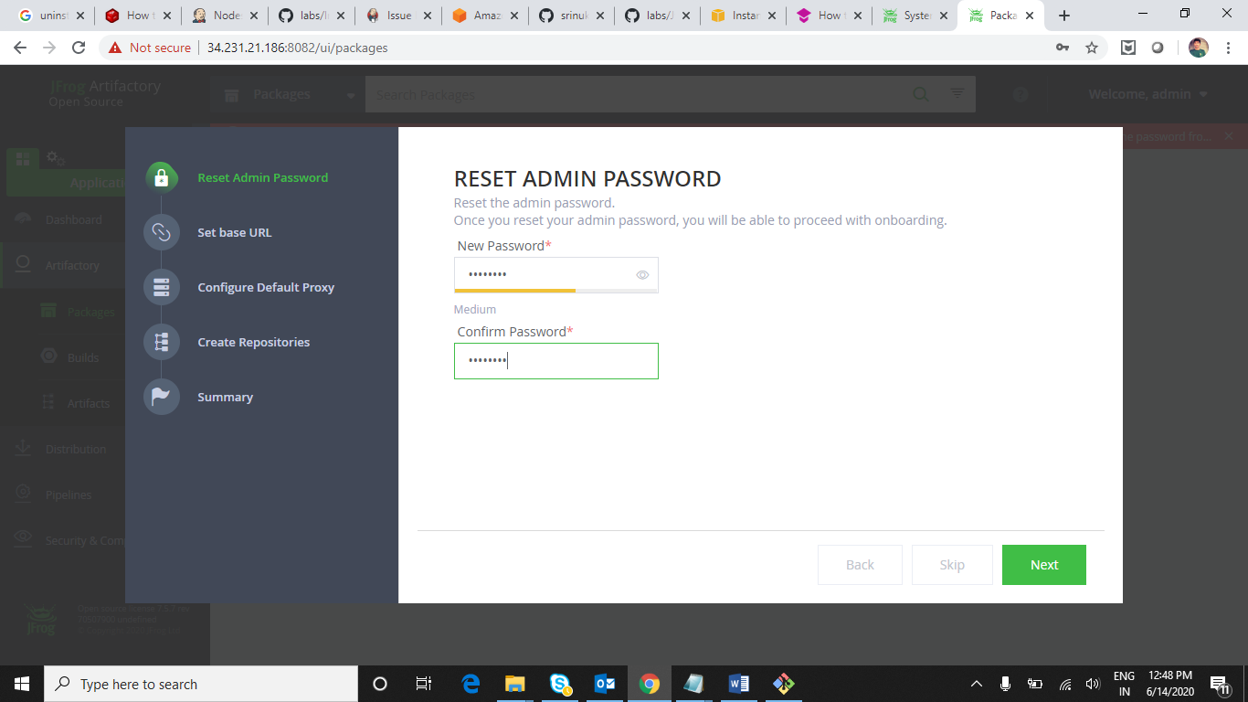

Project Binary files are stored under Artifactory

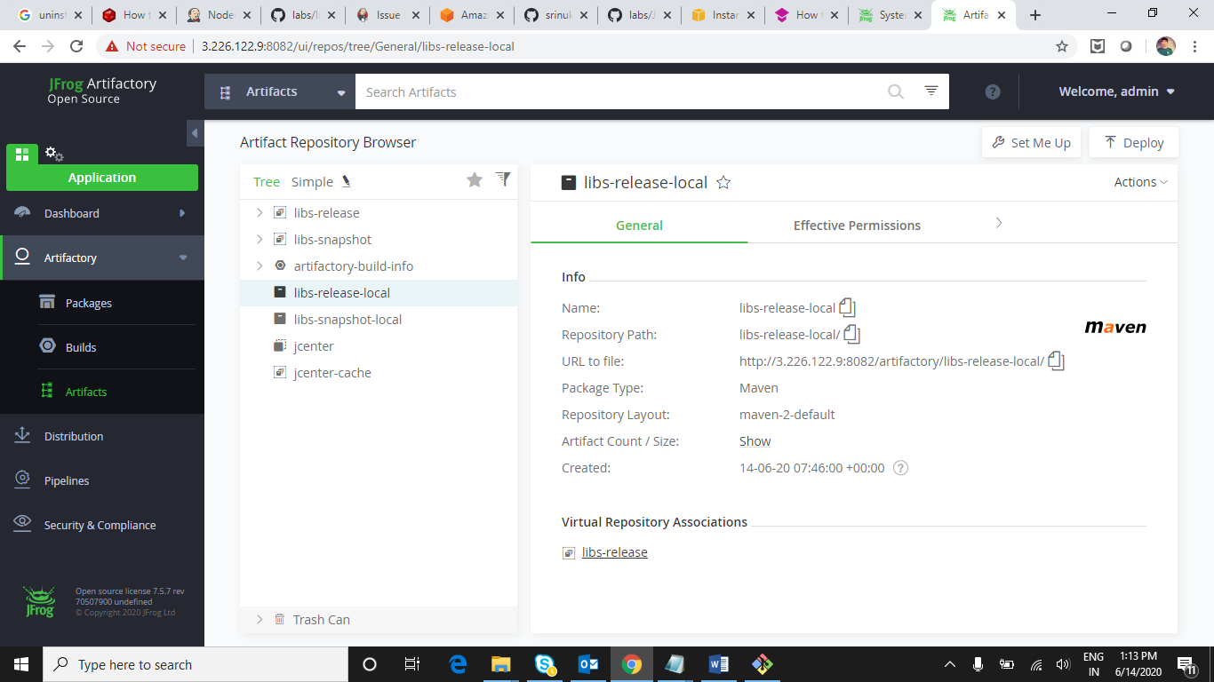

Create our own repository in Jfrog

In Jfrog we have 3 different types of repositories are there

1. Local
2. Remote
3. Virtual

Here we create local repositories for assuming deploying on different servers

Lets example create a Local repository practice

**Click on New Local Repository**

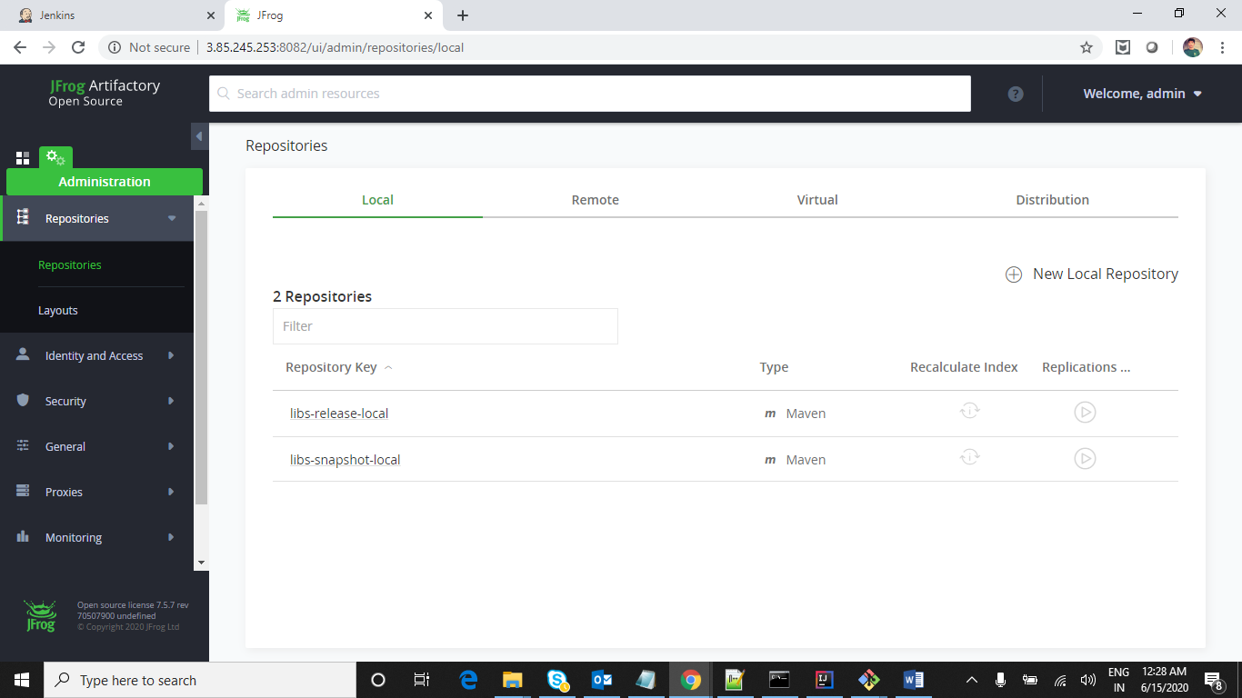

**Select Maven as we are deploying maven jar files**

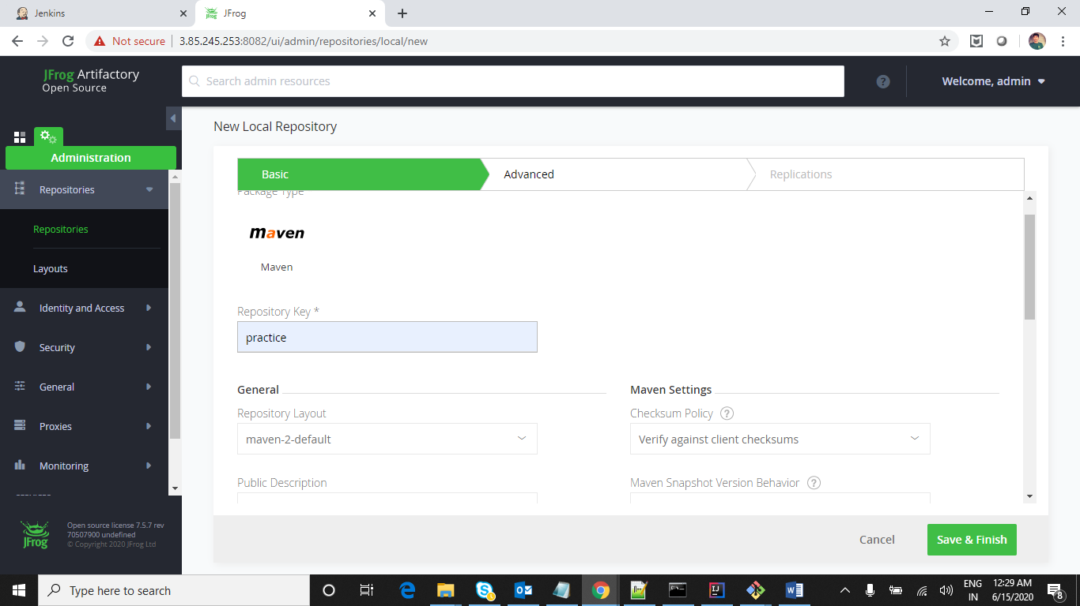

**Click Save and Finish**

It created local repo i.e practice

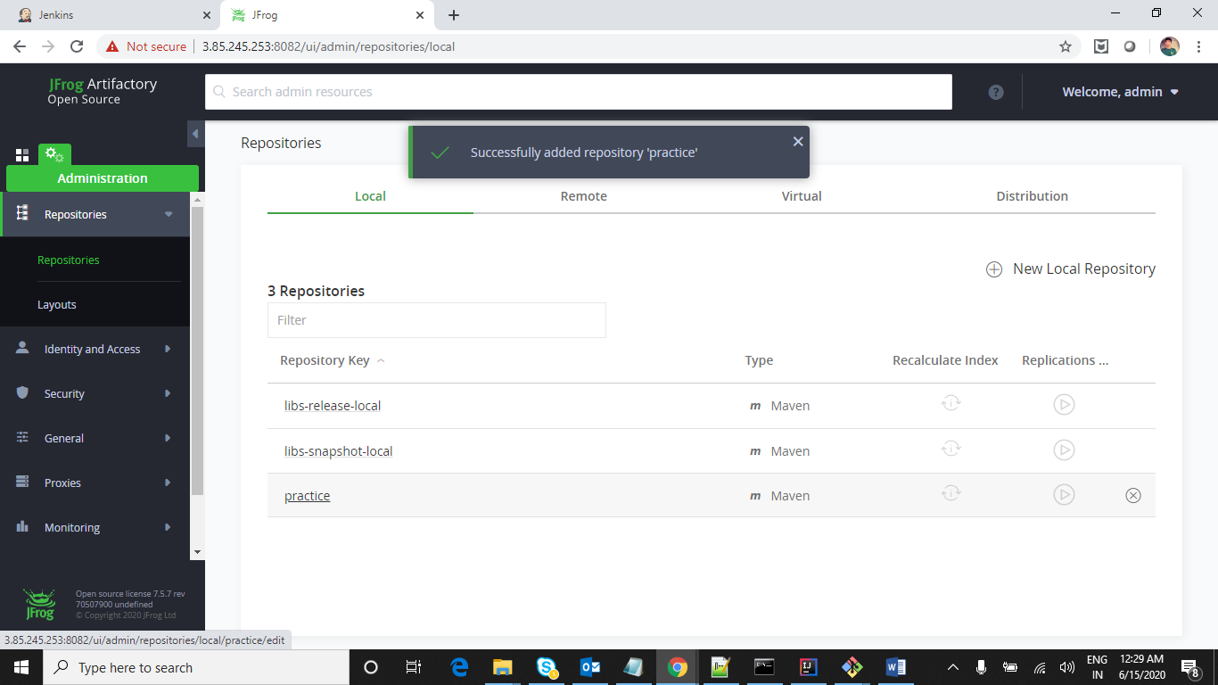

Now add remote repository which is retrieving dependencies from central repository

Select Remote Tab and click on new repository

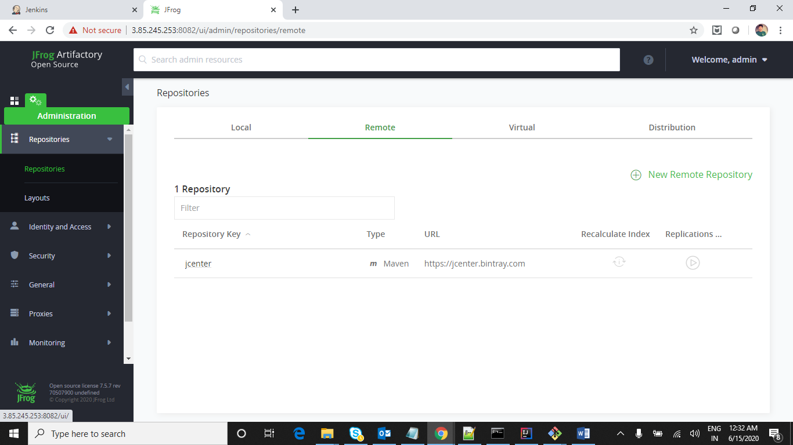

Add repository key as anything eg:- apache

<URL:-> <https://repo.maven.apache.org/maven2/>

Now click on Test and do Save and Finish

Now go to artifacsts and click on created local repo i.e practice and click on setMeUp which is present at left top

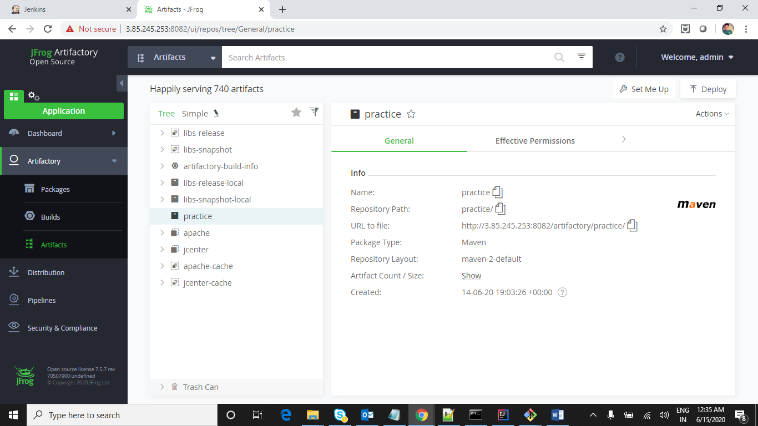

Now generate Settings.xml and distributionManagement tags which helps for deployment

Give password and click on arrow to generate settings.xml which helps when accessing particular artifacts you have access rights to deploy or not

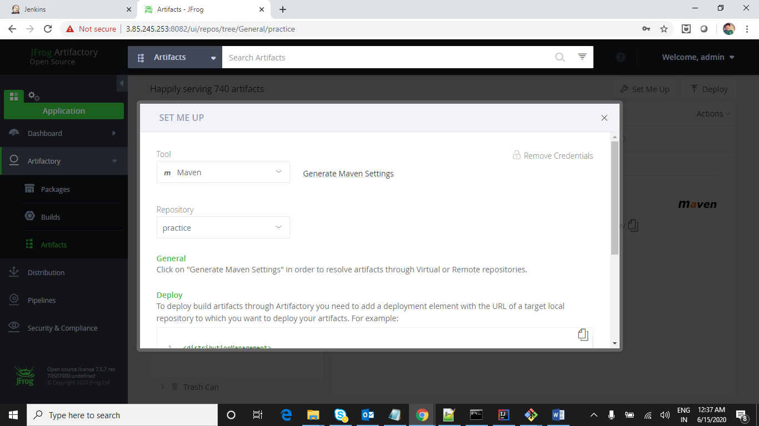

Click on Generate settings and click on Download Snippet which download download settings.xml

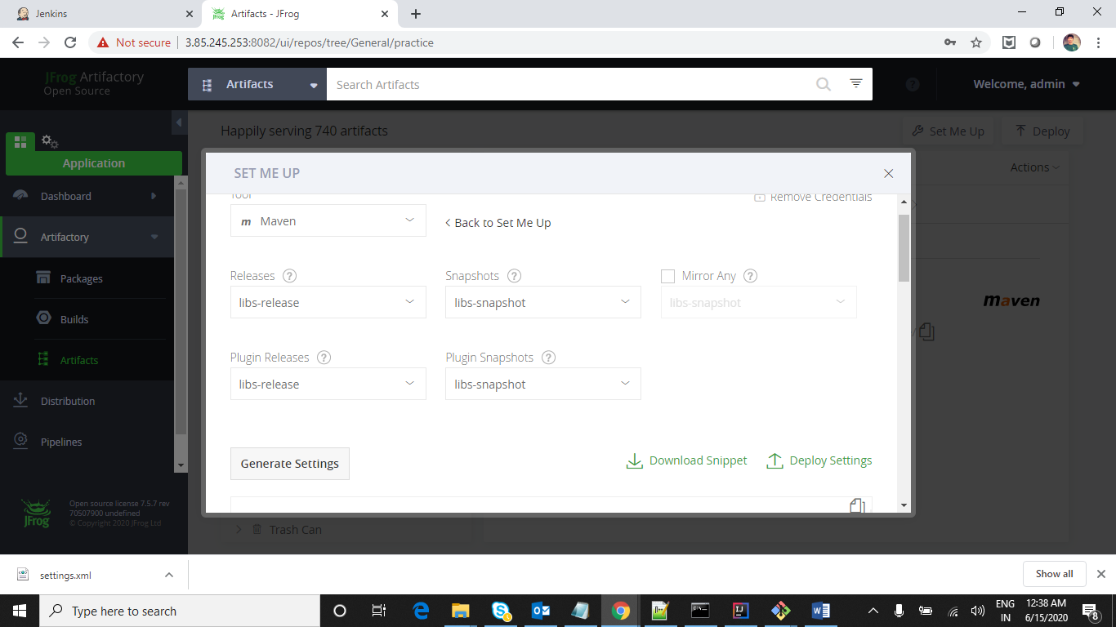

Save settings.xml under .m2 folder and change user name and password in settings.xml

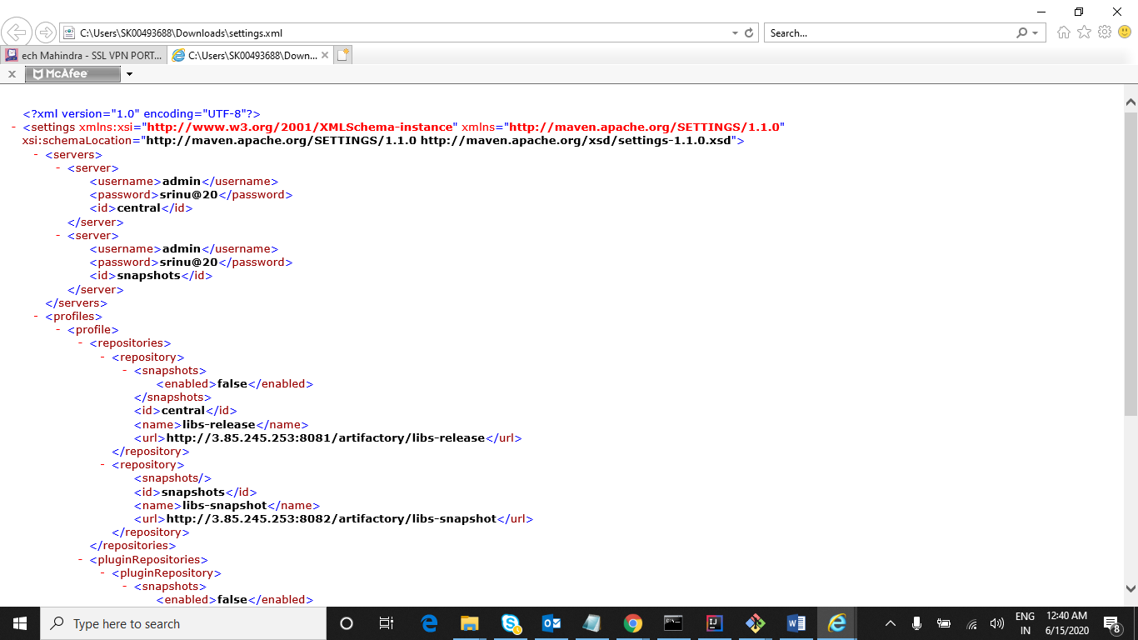

Now scroll down in artifactory where we can see distributorymanagement tag which will deploy in jfrog

And that should be placed in pom.xml

Example snippet:-

<distributionManagement>

<repository>

<id>central</id>

<name>ip-172-31-78-169-releases</name>

<url>http://3.85.245.253:8081/artifactory/practice</url>

</repository>

<snapshotRepository>

<id>snapshots</id>

<name>ip-172-31-78-169-snapshots</name>

<url>http://3.85.245.253:8081/artifactory/practice</url>

</snapshotRepository>

</distributionManagement>

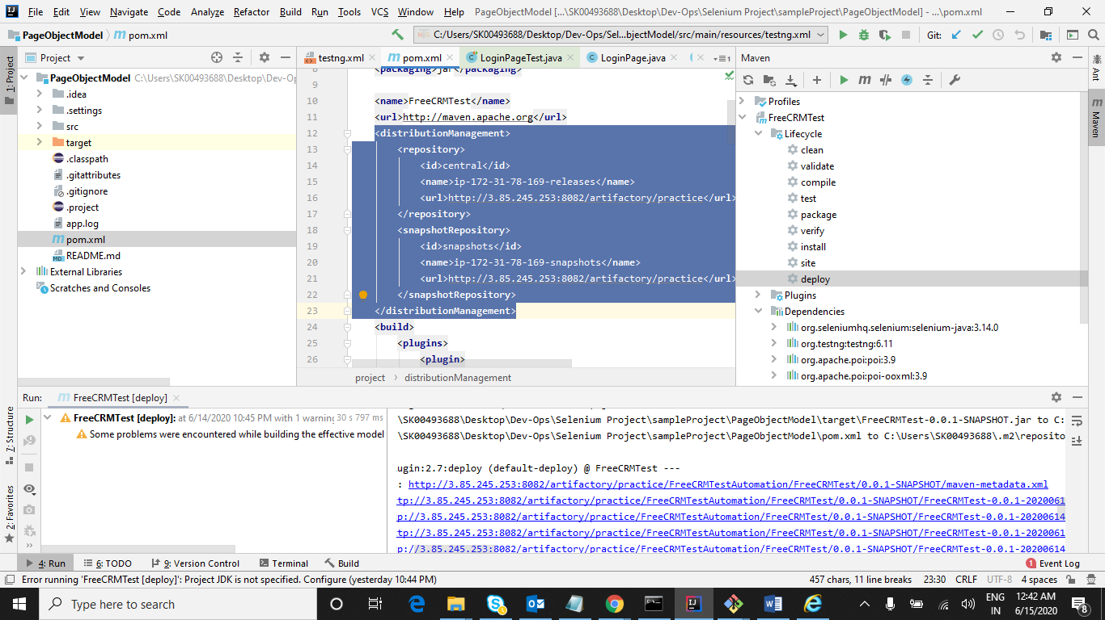

We can deploy artifactory files using 2 ways

1. Using Maven

Clone any project and give deploy as a maven goal it will deploy automatically to Jfrog artifactory

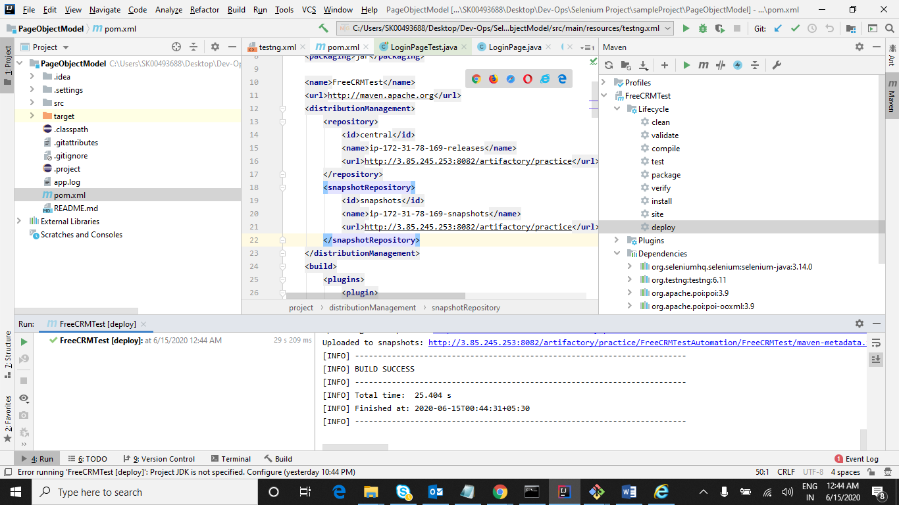

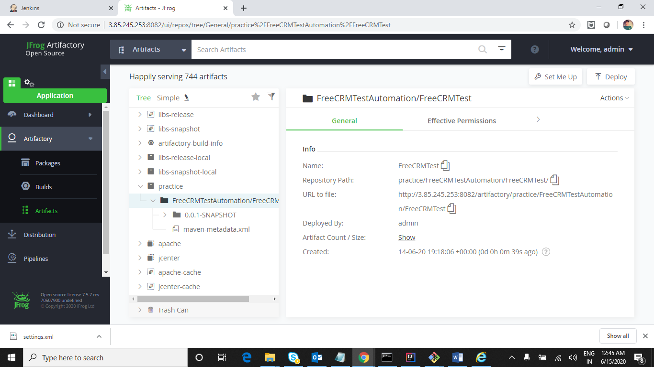

1. Jenkins

Download artifactory and install plugin

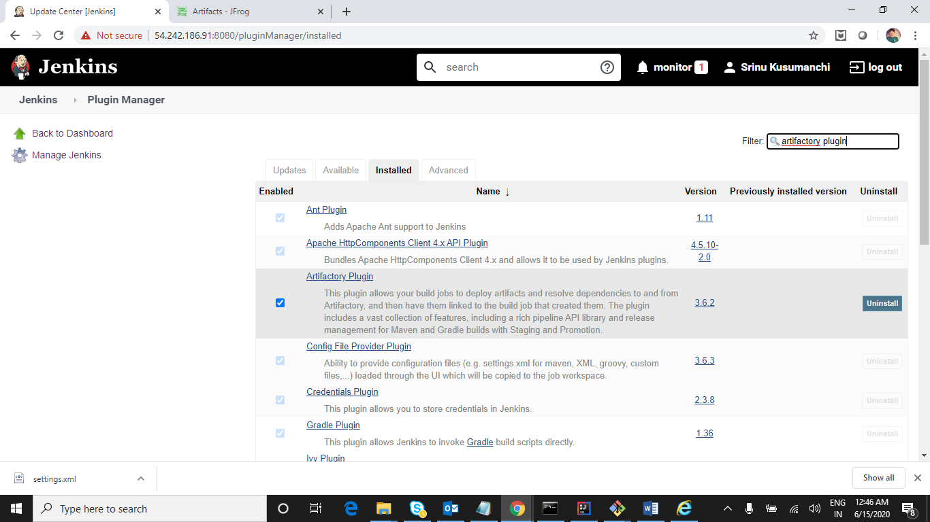

After installation we can see artifactory section under Configure system

Give details as below and click on apply and save

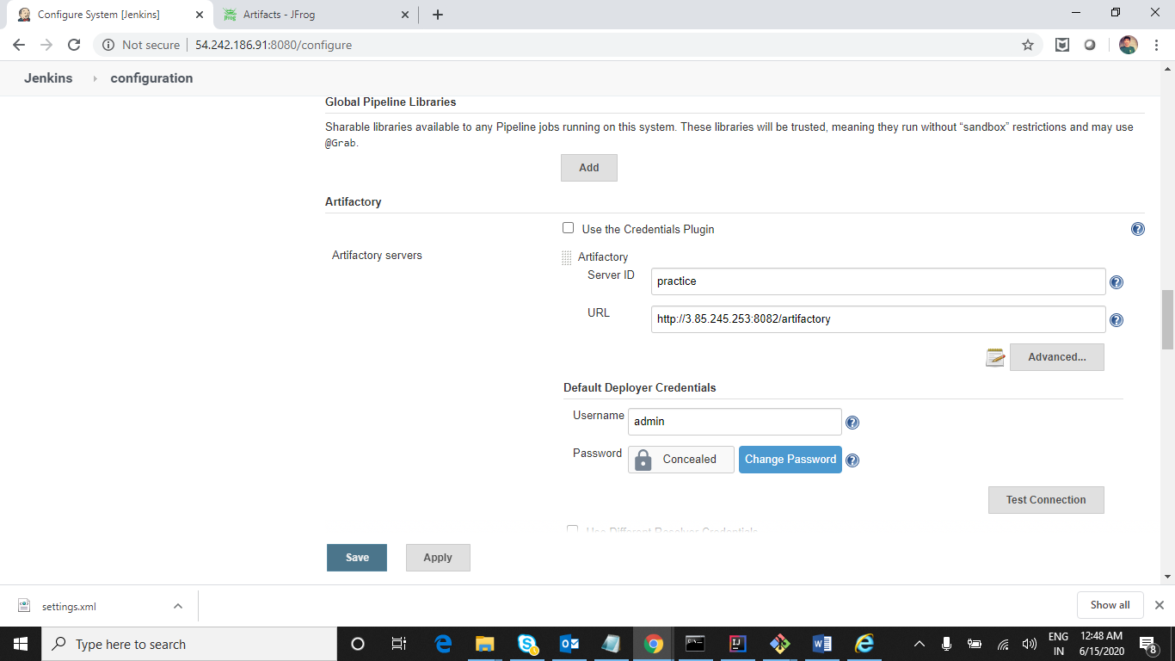

Now create a job and give clone url to download repository and artifactory details in build section and post build section to deploy to artifactory

Click on New Item and give project name and select maven project and click on Ok

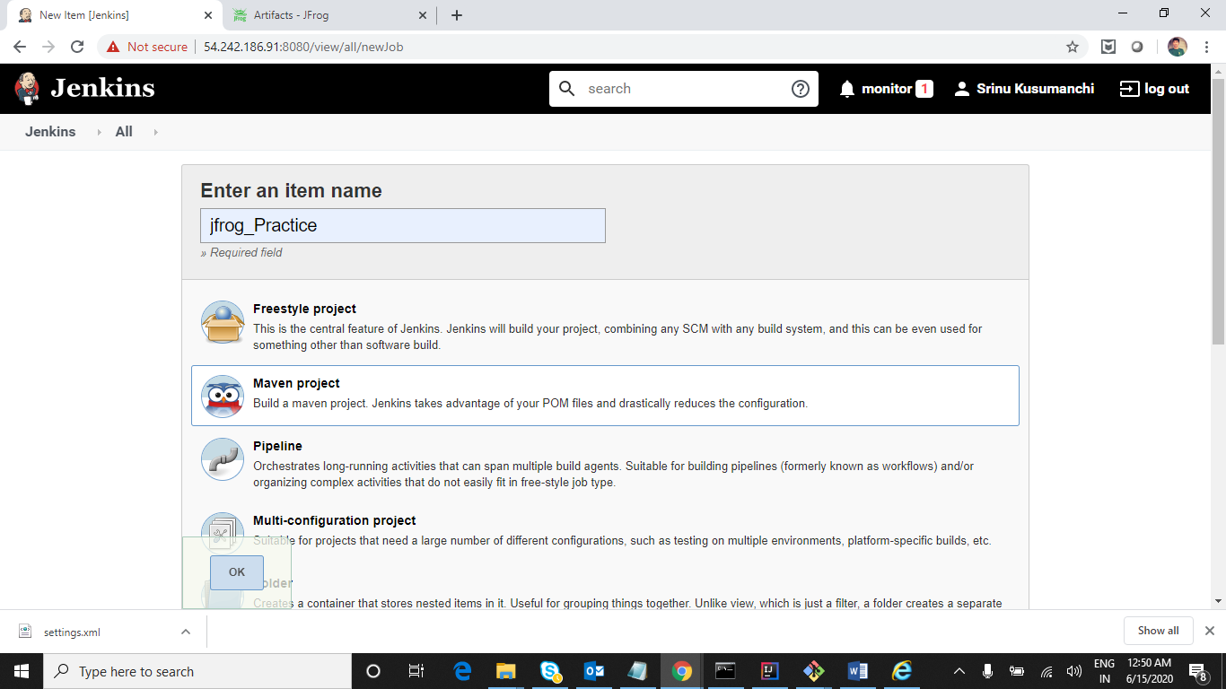

Give GIT Repository URL

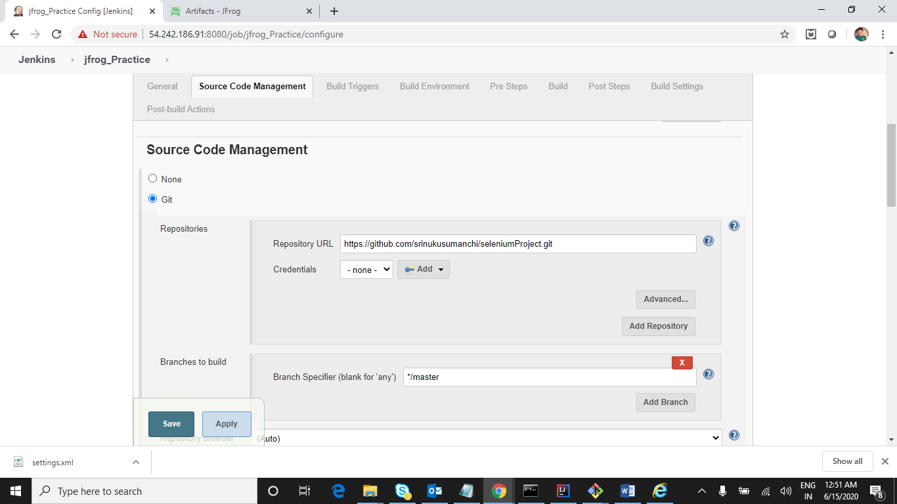

Now go to Build section and check Enable artifactory release management

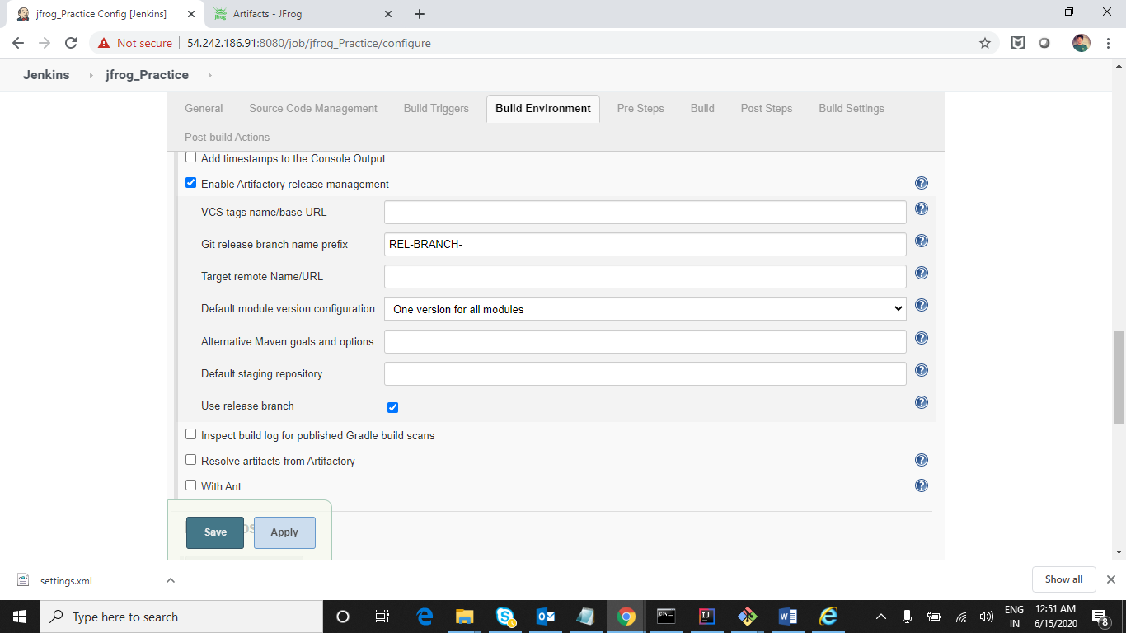

Now click on Resolve artifacts from Artifactory

It will show up artifactory server details already as we have given in configuration page under artifactroy section

Now refresh repository which comes are the repositories present in the jfrog

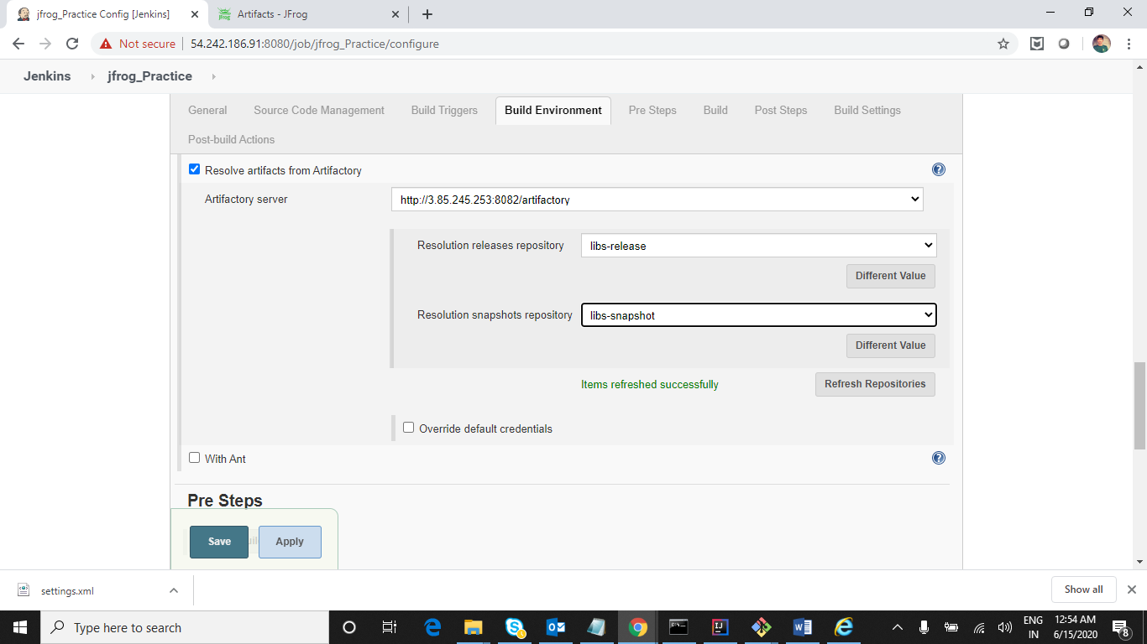

In Build section give install as maven goal

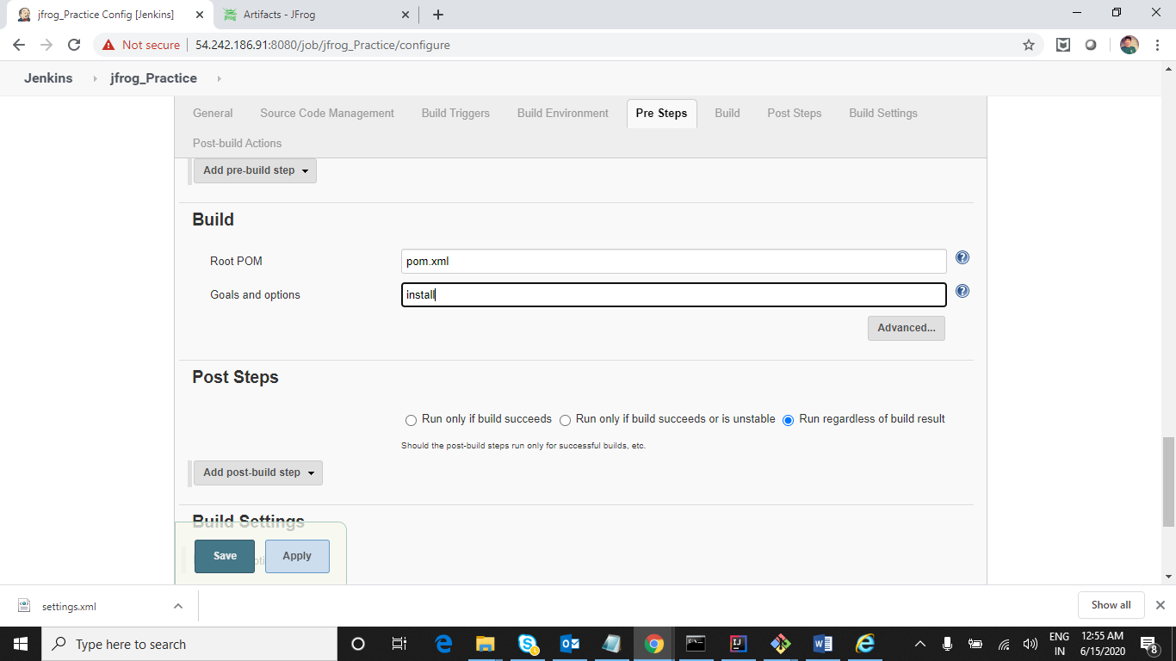

In post build section select Deploy artifacts to Artifactory

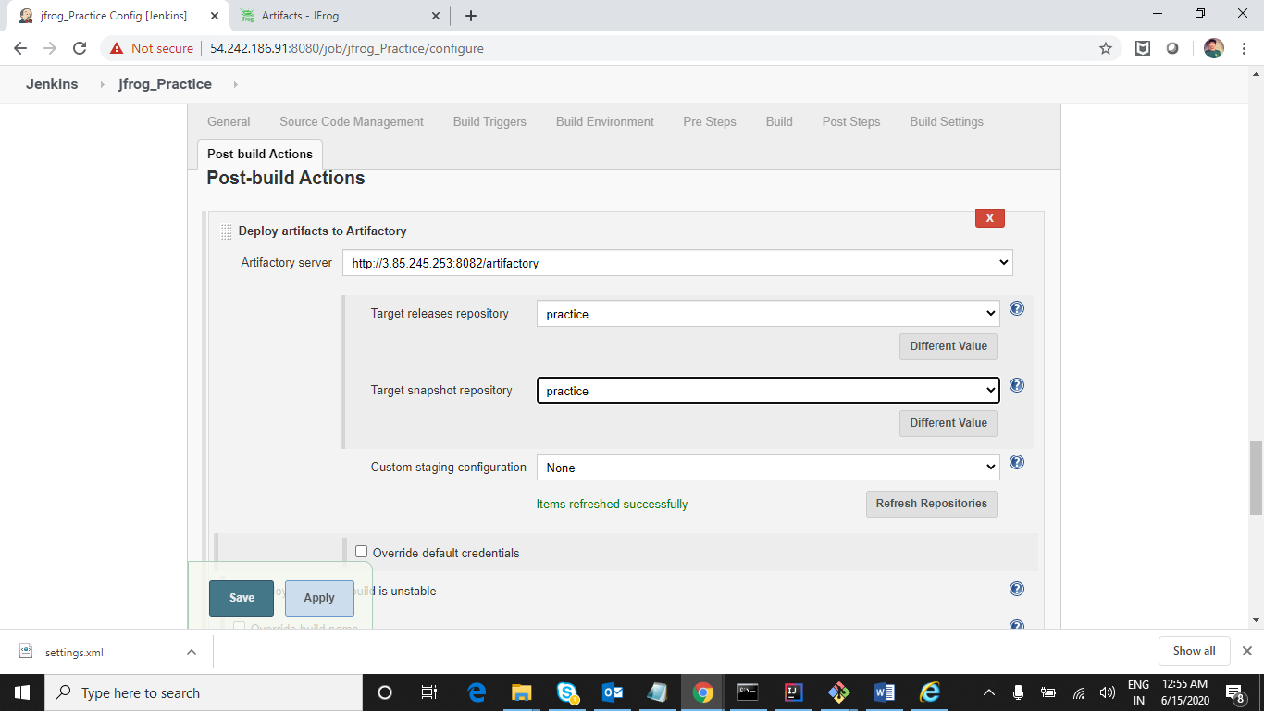

Now click on apply and save and do Build

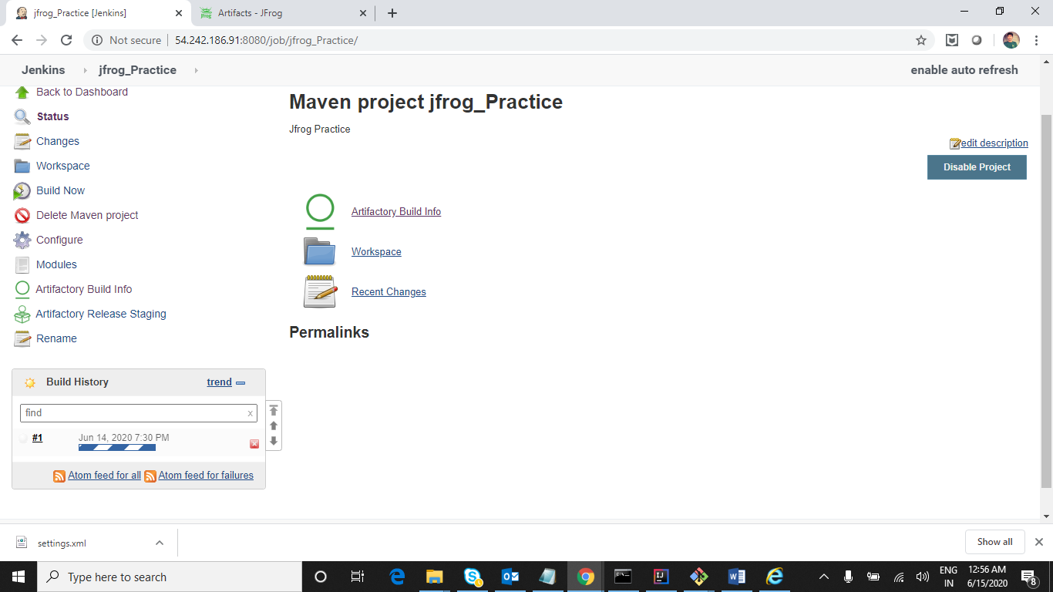

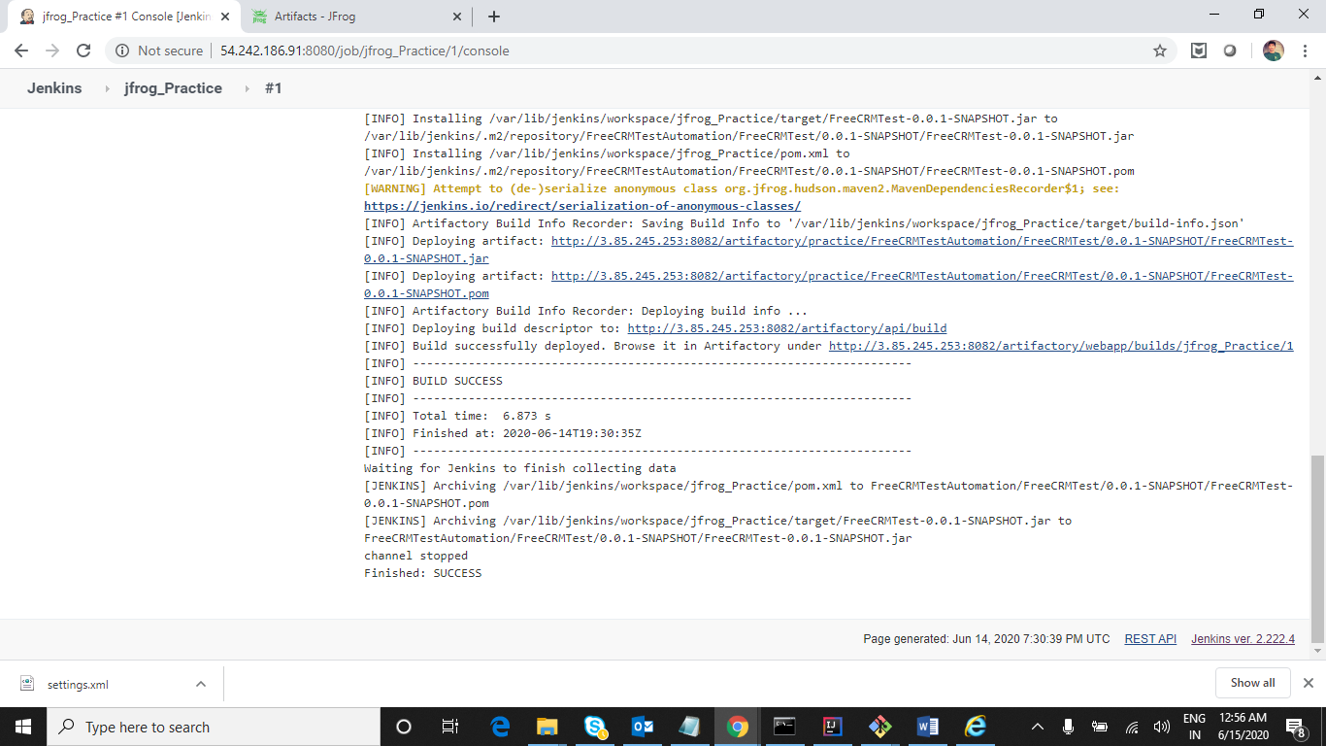

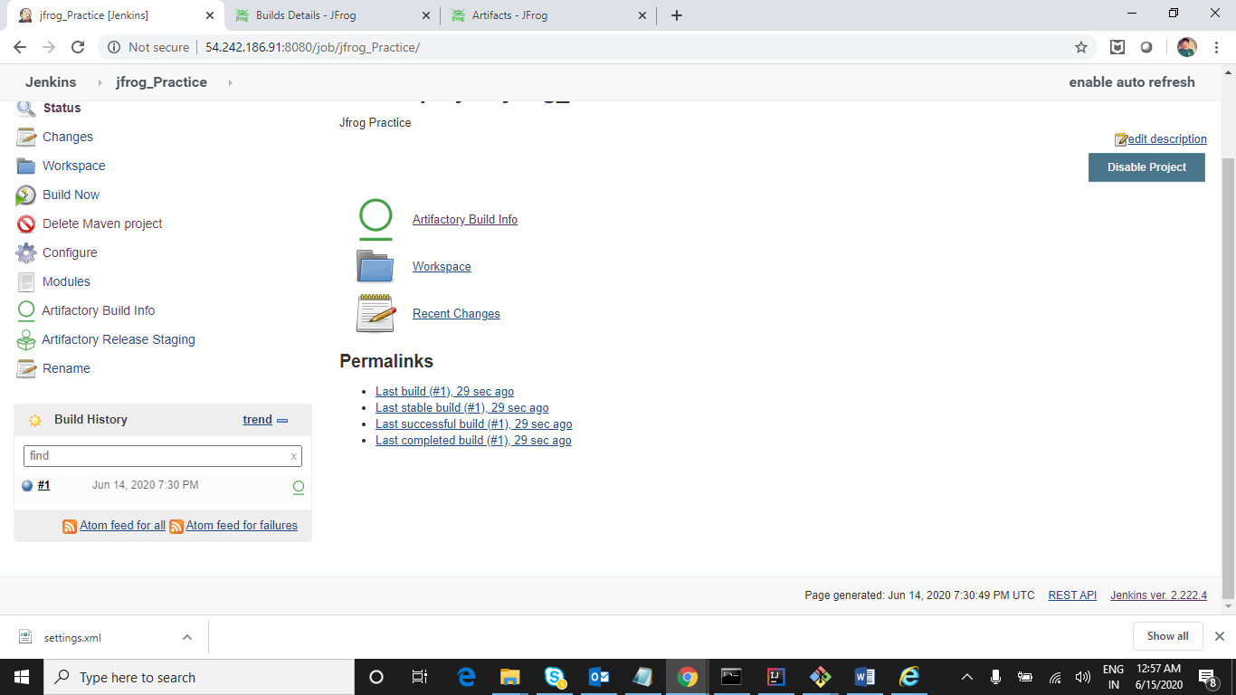

Now go to Jfrog artifactory and check our project is present or not

